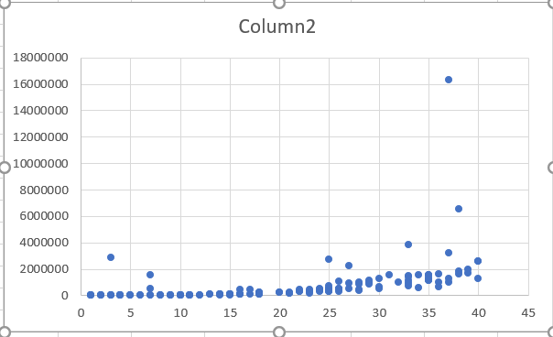

The output shows that the algorithm’s runtime is close to n^2, or is polynomial. The program, by master method looks like it is probably close to n^(log n). This is partly due to the fact that the program grows less than 2^n and the program is built on two sigma functions, in runtime that is.